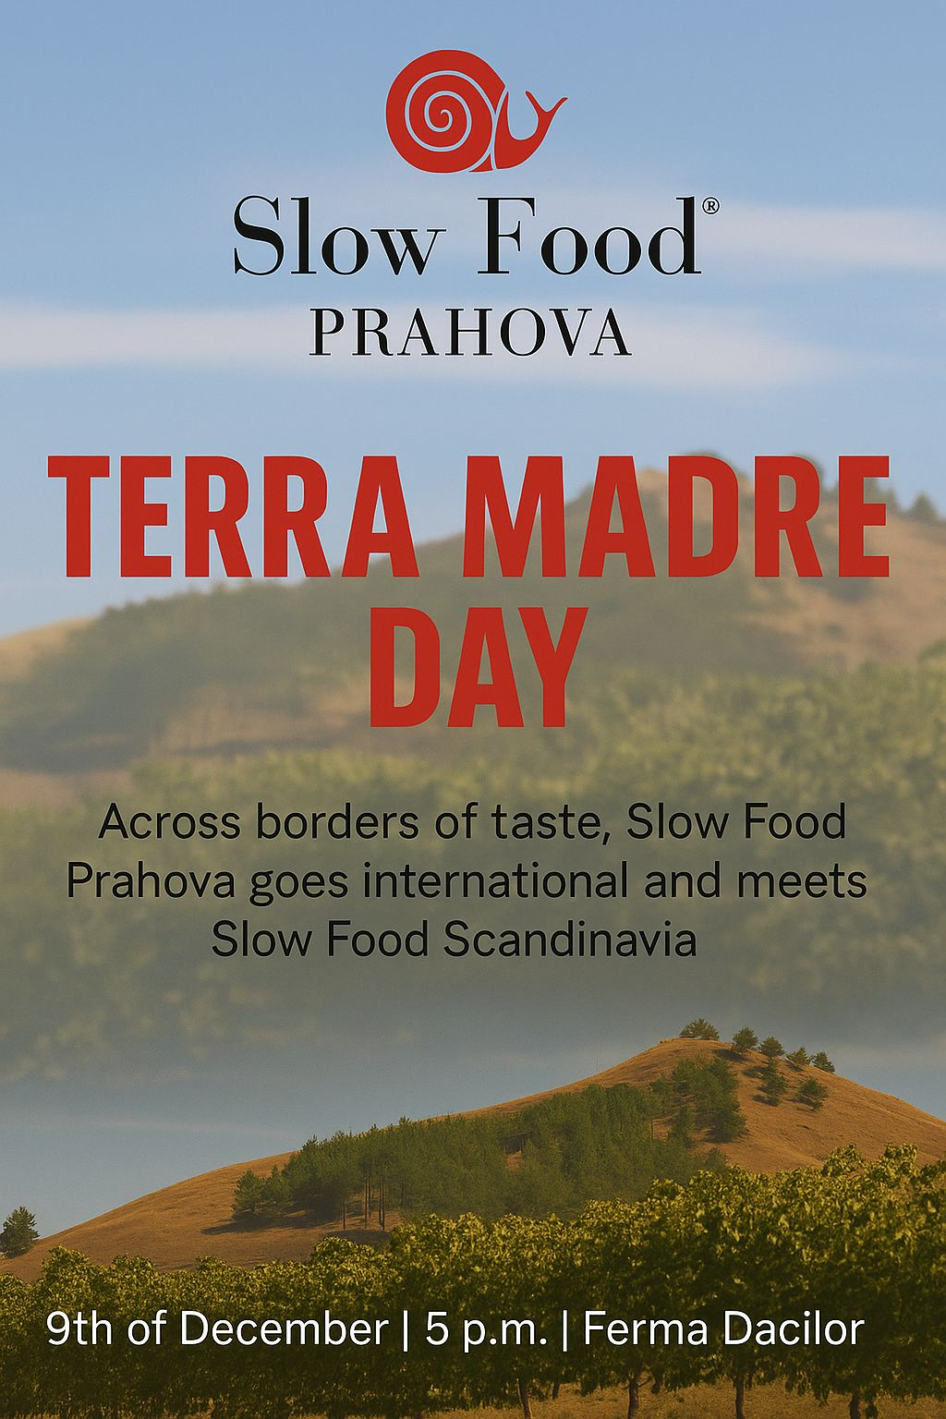
Local flavors, international collaboration, and a message for the future of gastronomy in Dealu Mare

Prahova has all the ingredients to become a regional gastronomic benchmark: the Dealu Mare terroir, artisanal producers with a clear identity, and an audience increasingly interested in food that is “good, clean, and fairly valued.” In this context, Slow Food Prahova is hosting a meeting at Ferma Dacilor (Tohani, Dealu Mare, Prahova) with a dual purpose: to strengthen the local community and exchange knowledge with guests from Scandinavia, on 9 December at 5:00 p.m. The event takes place around Terra Madre Day (10 December), the global Slow Food celebration dedicated to good, clean, and fair food, marked annually through local initiatives worldwide.
Why Prahova, why now?
Prahova stands for agricultural diversity, living traditions, and a tourism potential that is fully developed, anchored by the Wine Road. Slow Food Prahova’s mission is to connect artisanal producers, chefs, food education, and the public, so that the culinary experience remains authentic, sustainable, and properly valued. In the Terra Madre spirit, the 9 December meeting is designed as a working space: to clarify standards, put concrete examples on the table, and facilitate lasting links between local actors and international partners.
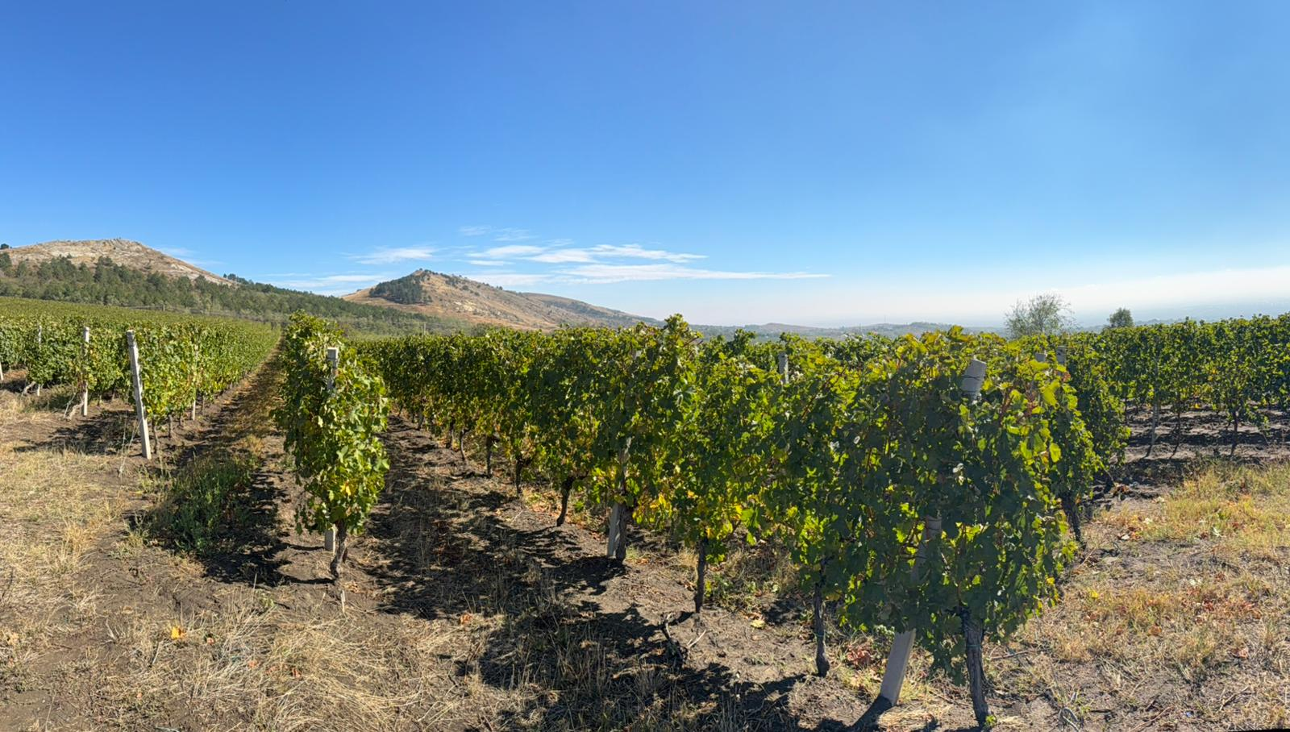
What the international component brings
Dialogue with Scandinavian partners highlights proven practices: what a functional short supply chain looks like, what taste education means for the general public, children, and adults, and how low-impact gastronomic events can be integrated into the tourism calendar of a wine region like Dealu Mare. This exchange supports the local objective of increasing the visibility of Prahova products, from artisanal syrups and preserves to cheeses, meats, and wines, within a coherent framework of quality and traceability.
A message to the community
Events held here can combine tastings, producers’ stories, and strategic discussions in an accessible format. Slow Food Prahova invites producers, restaurants, educators, communicators, and curious guests to get involved. The local community grows when we know the people behind the product, respect seasonality, and choose food with care for nature and for artisans’ work. It is a natural step already supported by Slow Food Prahova’s messages and projects focused on artisanal gastronomy and wine tourism in Dealu Mare.

Event details
- Date: 9 December 2025
- Time: 5:00 p.m.
- Location: Ferma Dacilor, Tohani – Dealu Mare, Prahova
- Context: around Terra Madre Day (10 December), the Global Day of Action for “good, clean & fair.”
terramadreday.slowfood.com

