

PISANG (BANANA) PARADE

- BANANA HISTORY
Bananas have been deeply ingrained in Indonesian culture. Throughout the archipelago, the bananas are recognised not just as a fruit but as embedded within culinary traditions, rituals, celebrations, and a silent witness to the long history of cultural exchange and trade. Initially known as Musa paradisiaca (fruit of paradise) in Latin, the banana is a heavenly blessing for Indonesia—almost everyone has access to them, since they are easily found in every home, marketplace, and festive celebration. The distinctive appearance, commonly bright yellow when ripe, the tender texture of the edible flesh, and natural sweetness are unmistakably familiar.

Bananas are remarkably well preserved in Indonesia’s memory. From archaeological remains to temple carvings, ancient manuscripts to colonial chronicles and modern writings, bananas tell a rich history in Indonesian food culture—one that goes far deeper than what meets the eye. To trace this story to its roots, we turn to the origins of banana domestication thousands of years ago.

The magical nature of bananas in Indonesia lies in their place on the table. Given abundant varieties, make it familiar yet versatile for comfort food and a festive treat. As a true gift from nature, the banana can simply be enjoyed raw at perfect ripeness or, with a few efforts of preparation through boiling, steaming, drying, or frying, the bananas transform into an array of delicacies. Alongside rice, coconuts, yams, taro, and tubers, bananas have long been treasured in Javanese agriculture and spirituality, woven into the very fabric of everyday life since ancient times.

Food culture is a mirror of history, and bananas' roles evolve from subsistence to rituals, part of cultural identity, and finally end up in modern fusion. When bananas started by the time of the great Hindu–Buddhist kingdoms, bananas appeared in temple reliefs, feasts, and sacred rituals, becoming part of both spiritual and culinary traditions. The arrival of Islam does not diminish the roles of bananas but instead enriches the banana food culture further: sweet coconut-milk desserts like kolak became central to Ramadan iftar, while fried bananas (pisang goreng) evolved into popular daily snacks.

As like Serat Centhini (Javanese manuscipts), we learnt that while they already mastered processing techniques, our ancestors did not abandon local wisdom on fresh bananas. Many varieties local bananas calles as like Ambon, Emas, Gabu, Pulut, and Raja continue to be valued as everyday desserts. Especially, Pisang Raja, it’s not just a fruit. Its elegant shape, flavour, and delightful taste serve as a landmark of honour, often gifted to respected guests or relatives. For generations, it has become the table banana at Javanese gatherings, a role that still endures today.Beyond the fruit itself, banana plants shaped Javanese dining traditions. The Serat Centhini describes bark and leaves used as plates for side dishes like goat curry, or upih leaves for cooking rice. Drinks such as sriawan, made from kluthuk bananas, were ritual companions to tea, coffee, and herbal tonics. In the other island is Sulawesi. Toraja community Indigenous Poeples in there , young banana leaves are part of funeral ceremonies (Widjaja, 1988). Among the Tolaki, banana serves are vital for dispute resolution (Koodoh & Idaman, 2013).

Along with the early manuscript, bananas' roles were immortalised in temple reliefs, oral tradition, rituals, symbolism, and cultural identity. The famous carving in Borobudur Temple, built between the 8th and 9th centuries by the Syailendra Dynasty, features bananas used in offerings and foods. This carving confirmed the centrality of bananas in the Indonesian community. For thousands of years, they have not just been a food but, more importantly, have occupied a central place in religious rituals and ceremonies. Although the newer belief has made offering less relevant for many ethnic groups, the close connection between ritual traditions and bananas expresses a strong bond between humans and nature, making the banana irreplaceable, as they are required to preserve cultural identity (Permanasari, 2017). This cultural identity is also a blessing as it provides an invisible medium for conserving banana agrobiodiversity (Nawireja, Vellema, & Stoorvogel, 2023).

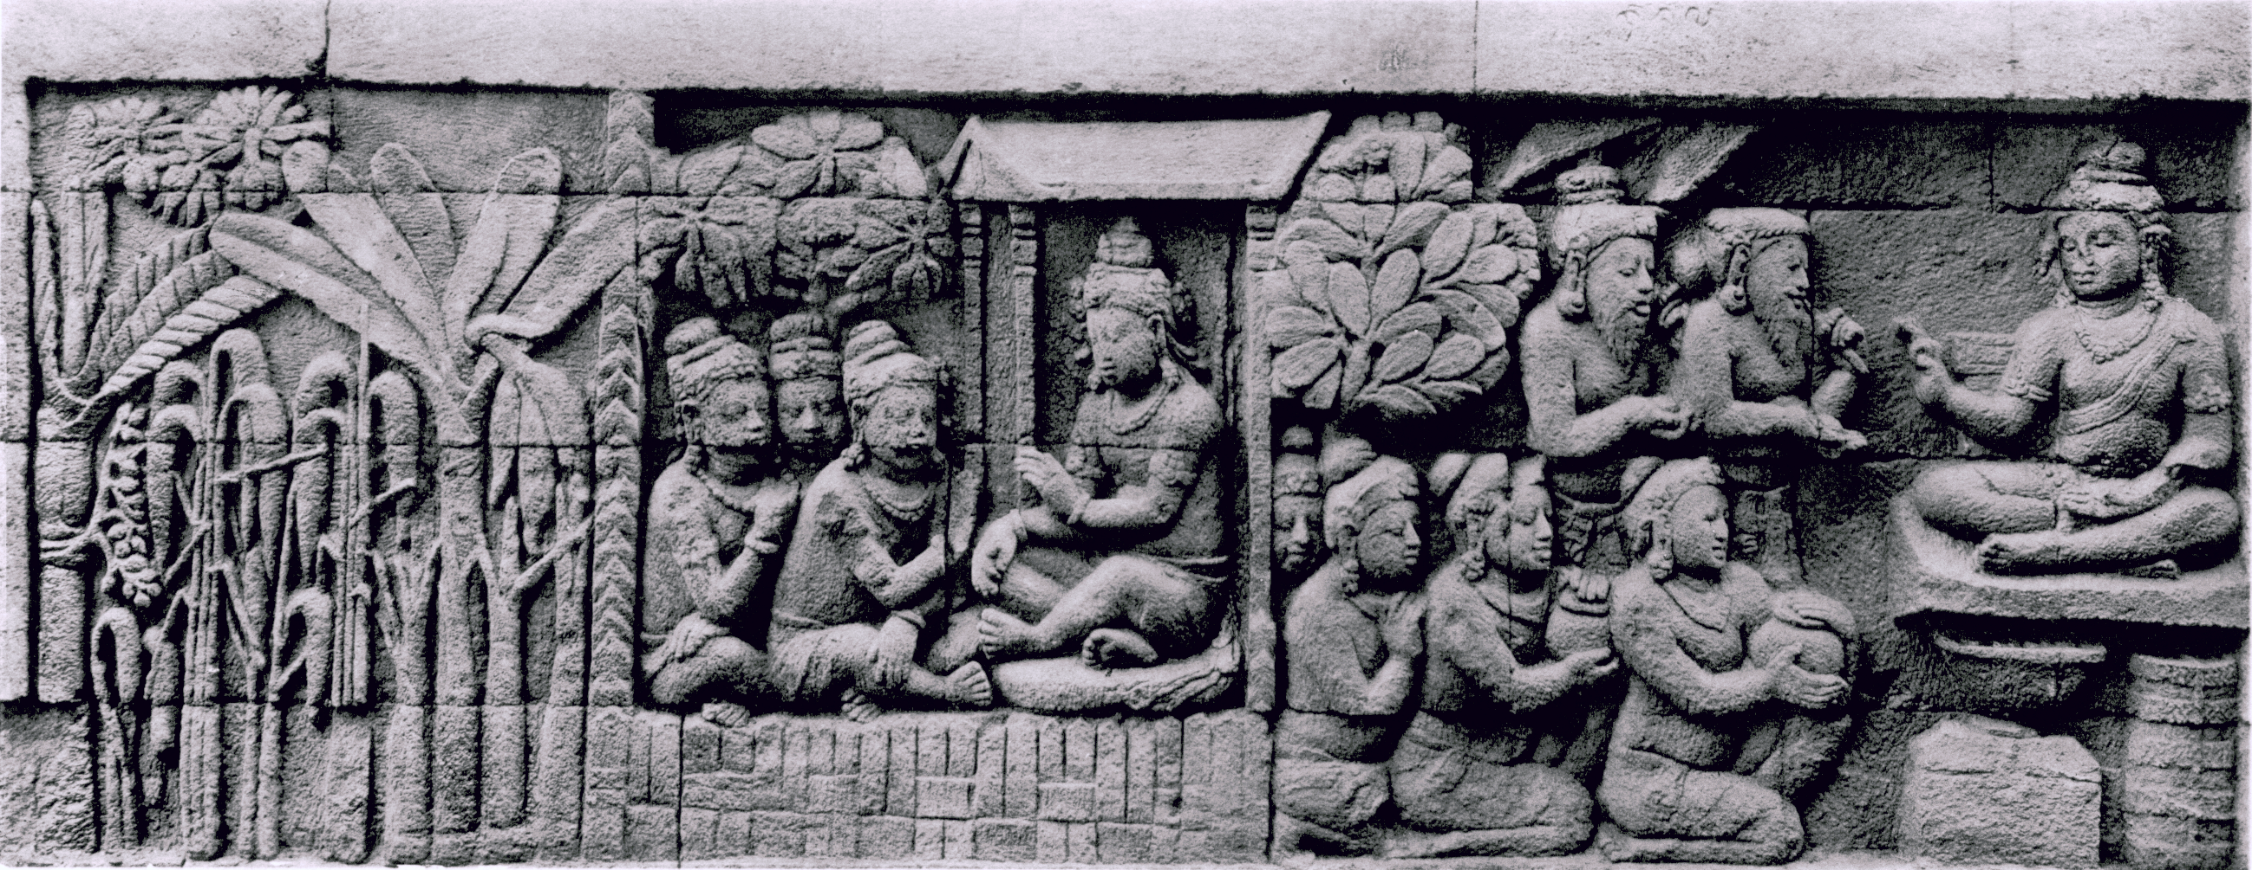
Pic. 1. Relief of Banana on Borobudur Temple

- INDONESIAN BANANAS
Bananas are tropical monocot plants deeply rooted in daily life across the Indonesian Archipelago. Banana fruit in Indonesia language is called Pisang, and in many local names such as cau, gedang (Java), biyu (Bali), punti, saba (Lampung, Sulawesi, Kalimantan), biu, kola, mutu, huni, wusa (Nusa Tenggara), unti (Sulawesi), nando, rumaya, pipi (Papua), kula,lika,pelewa, phitim,phudi,uki,talah,mah,Iani,biyeh, pagie, etc, that is reflecting their cultural significance and widespread presence throughout the country.
Botanical Classification
Kingdom : Plantae
Division : Magnoliophyta
Class : Liliopsida
Order : Zingiberales
Family : Musaceae
Genus : Musa
Species : Musa acuminata, Musa balbisiana, Musa paradisiaca, Musa textilis, Musa troglodytarum, and others
Bananas (Musa spp.) are number one favorite fruit in the world (FAOSTAT, 2021). Generally, bananas are grouped into cultivated and wild types. Cultivated bananas are those with economic value and are traded, while wild bananas are not. Wild bananas typically grow naturally along riverbanks, forest edges, or deep in the forest. Sometimes they tend to have small fruits with flesh full of seeds. Wild bananas as like pisang uter, pisang klenthik (Java area), pisang mauli. Pisang uter is The Ark of Taste Catalogue

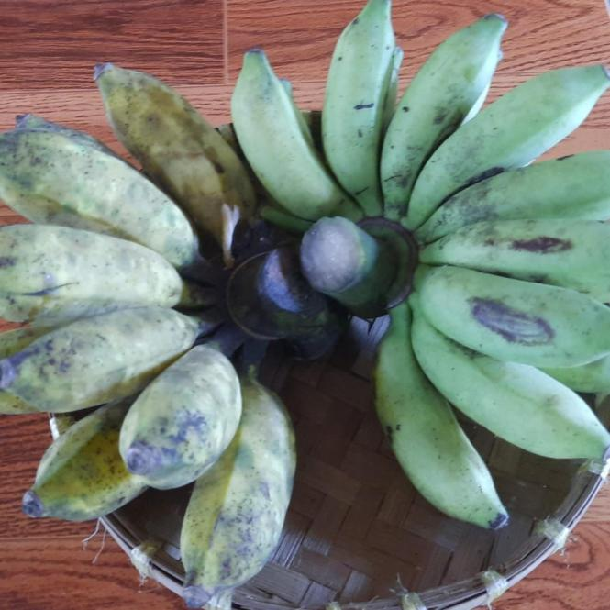 | 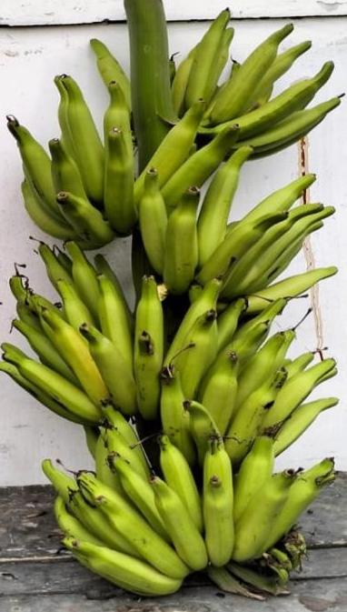
Pic.2. Pisang uter ( r ) and Pisang klentik (l) | Pic. 3. PIsang Mauli

Banana fruits grow in clusters called bunches, with each tier neatly arranged like fingers, known locally as a sisir. Unripe bananas are dark green, and as they ripen, their skin may turn yellow, orange, red, purple, black, or even remain a dull green.
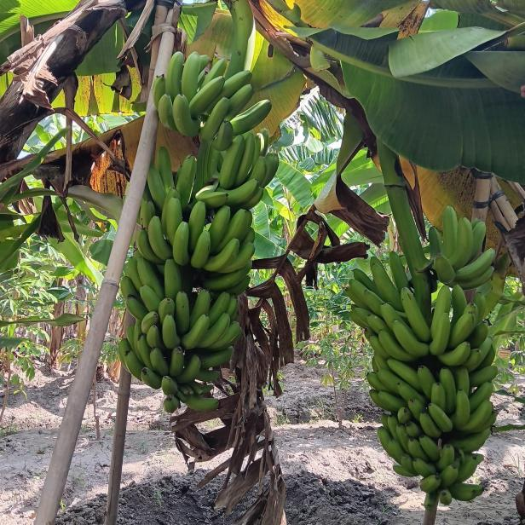 | 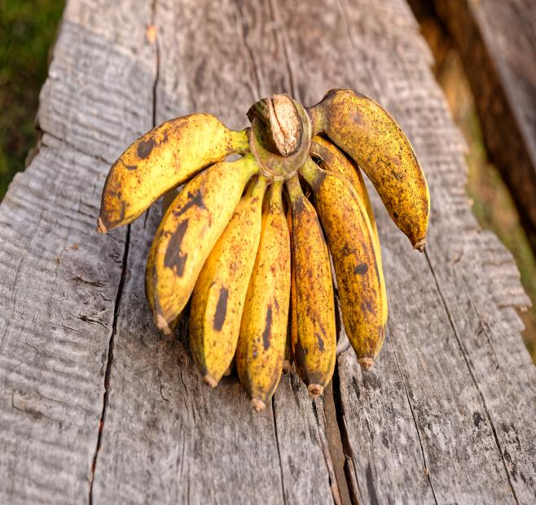
Pic.4. Bunches | Pic.5.Sisir (Finger figure of banana)

Commonly in Indonesia, base on the use. Bananas are divided into non-consumable and consumable bananas. Non-consumable bananas are bananas that are utlilized not as a food. Non-consumable bananas be apart of ritual purposes, decoration or other needs. As like pisang songgo buwono / songgo langit as important part of Yogyakarta Kingdom ritual, pisang Abaca (Manila Hemp) which is harvested for its fiber-rich stalks, used in sustainable textiles and high-quality paper products. Pisang Raja Seribu (Thousand-Hand King Banana) which produces long bunches that can reach up to three meters in length. And pisang monyet (monkey banana) has redish colour of leaf beuty part of decoration.
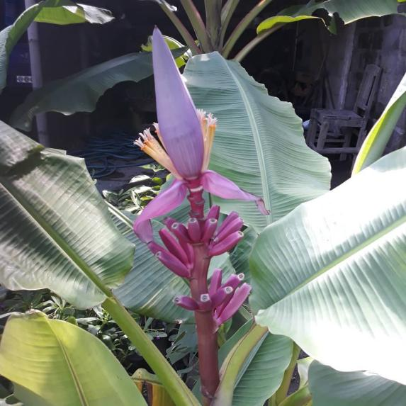 | 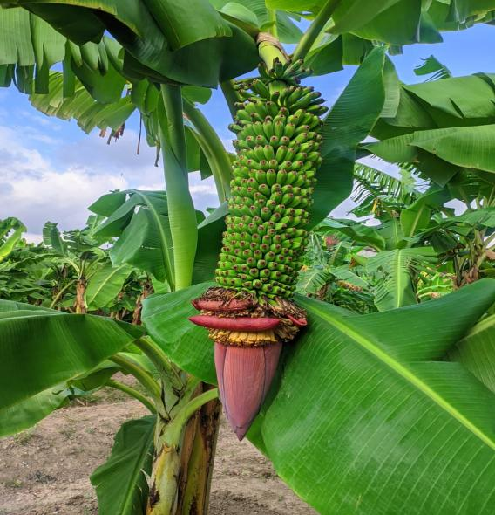
Pic. 6. Pisang Songgo Buwono | Pic. 7. Pisang seribu

Consumable bananas are bananas fruit as a food. Banana (Pisang) consume are generally divided into two categories:
1. Dessert Bananas (Pisang Meja) - Ready to eat
These bananas can be eaten fresh once ripe, without any further processing. They are sweet and have soft flesh. Examples include Pisang Raja (King Banana) which is known for its rich sweetness and good apprience. Pisang Ambon is aromatic / fragrant banana, Pisang Barangan (Barangan Banana) which is popular in North Sumatra, and Pisang Mas (Golden Banana) which is small in size, thin-skinned, and very sweet.
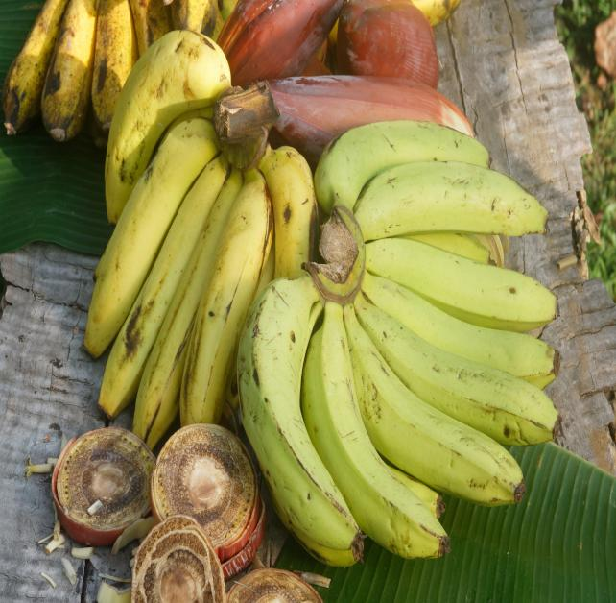 | 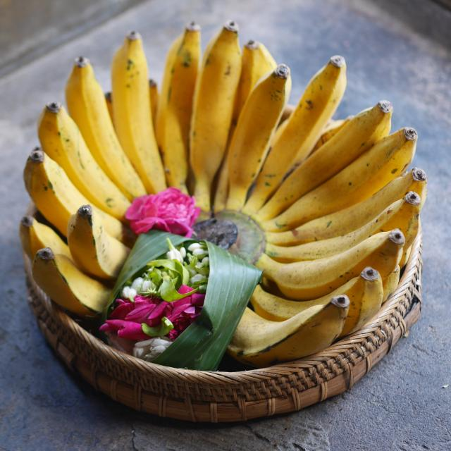
Pic. 8. Pisang Ambon  (The Art of Taste Catalogue) | Pic.9. Pisang Raja  (the Ark of Taste Catalogue)

2. Plantian Banana (Pisang Olahan)
Unlike dessert bananas, plantain banana are not ideal for eating fresh. They are best enjoyed after process as like cooking (fried, boiled, steamed, grilled) or chips flake flour, to bring out their excelent texture and taste. These bananas are less sweet or even bland, with firm or dense flesh, sometimes even hard when ripe. Examples include Pisang Kepok (Kepok Banana) which is perfect for frying, steaming, grilling, or making kolak (an Indonesian dessert made by simmering ingredients like banana, sweet potato, cassava, or pumpkin in a rich, sweet coconut milk broth infused with palm sugar and fragrant pandan leaves) during Ramadan. Other examples are Pisang Tanduk (Tanduk Banana) which is very large and curved like a horn, ideal for chips or fritters.and Pisang Nangka (Jackfruit Banana), known for its reddish-yellow flesh with a firmer texture, ideal present steam processed banana
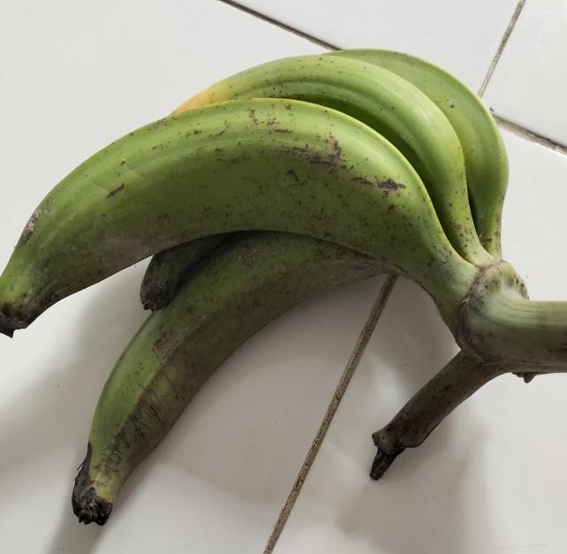 | 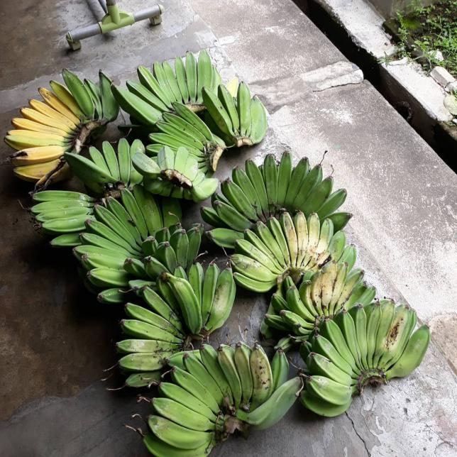
Pic.10. Pisang Byar | Pic. 10. Pisang Kepok  (The Ark of Taste Catalogue)

Banana diversity in Indonesia goes far beyond just fruit types. There are several unique varieties with unique, such as Pisang Lase (Lase Banana) which is capable of producing more than one bunch in a single fruiting period; Pisang Byar (banana has no blossom) , Pisang morosebo (dwarft banana, because hight stem under one meter). Or pisang in Raja Empat Papua, similar type as like pisang kepok but they have giant posture because the situation site (forest). Pisang Genderuwo/Potho Merah (Red Demon Banana) which features thick, glossy red skin. Pisang Klutuk (Klutuk Banana), valued for its wide, flexible, and strong green leaves, often used for wrapping and serving food. Small slice of green pisang kluthuk gives spesific taste of rujak (Indonesian fruit salad).
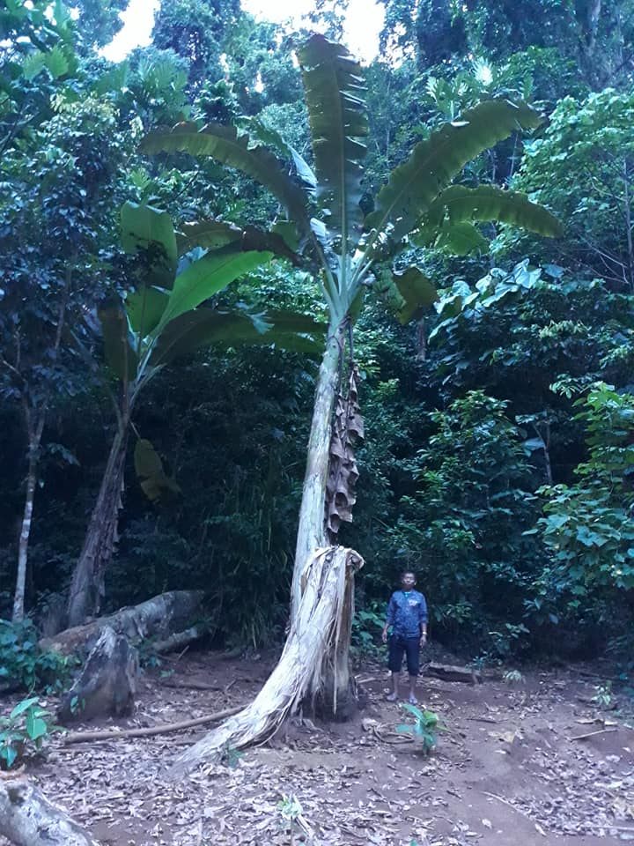 | 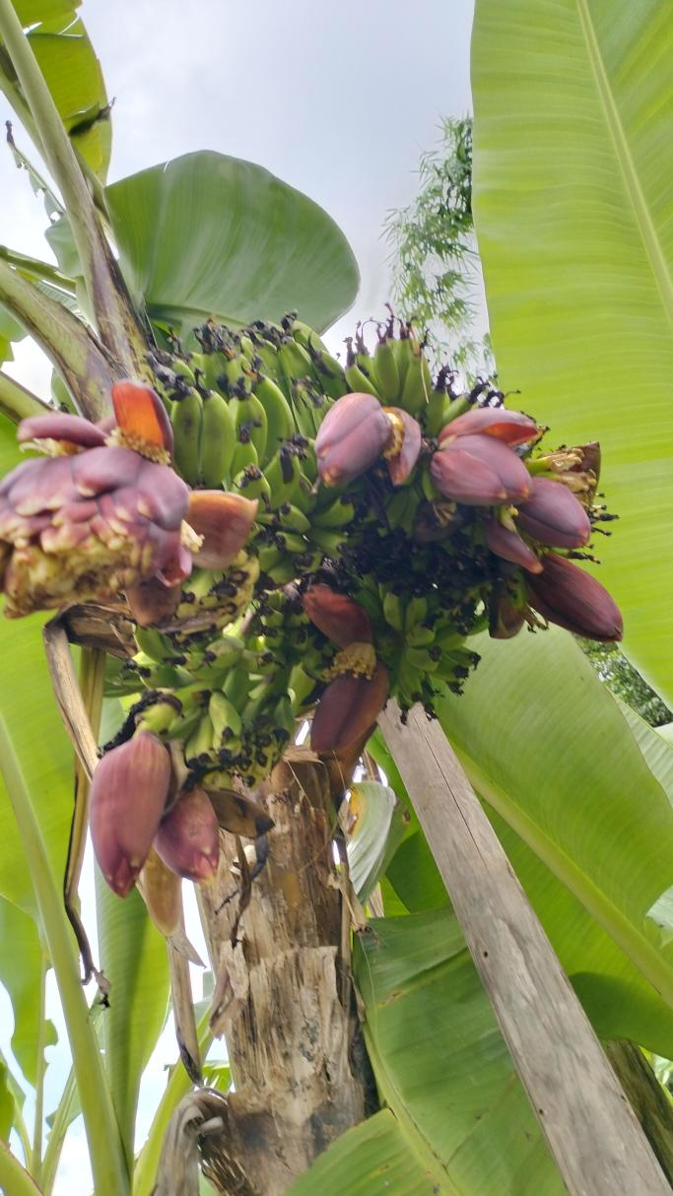
Pic. 11.Banana tree  at seashore Raja empat Papua | Pic. 12. Pisang lase
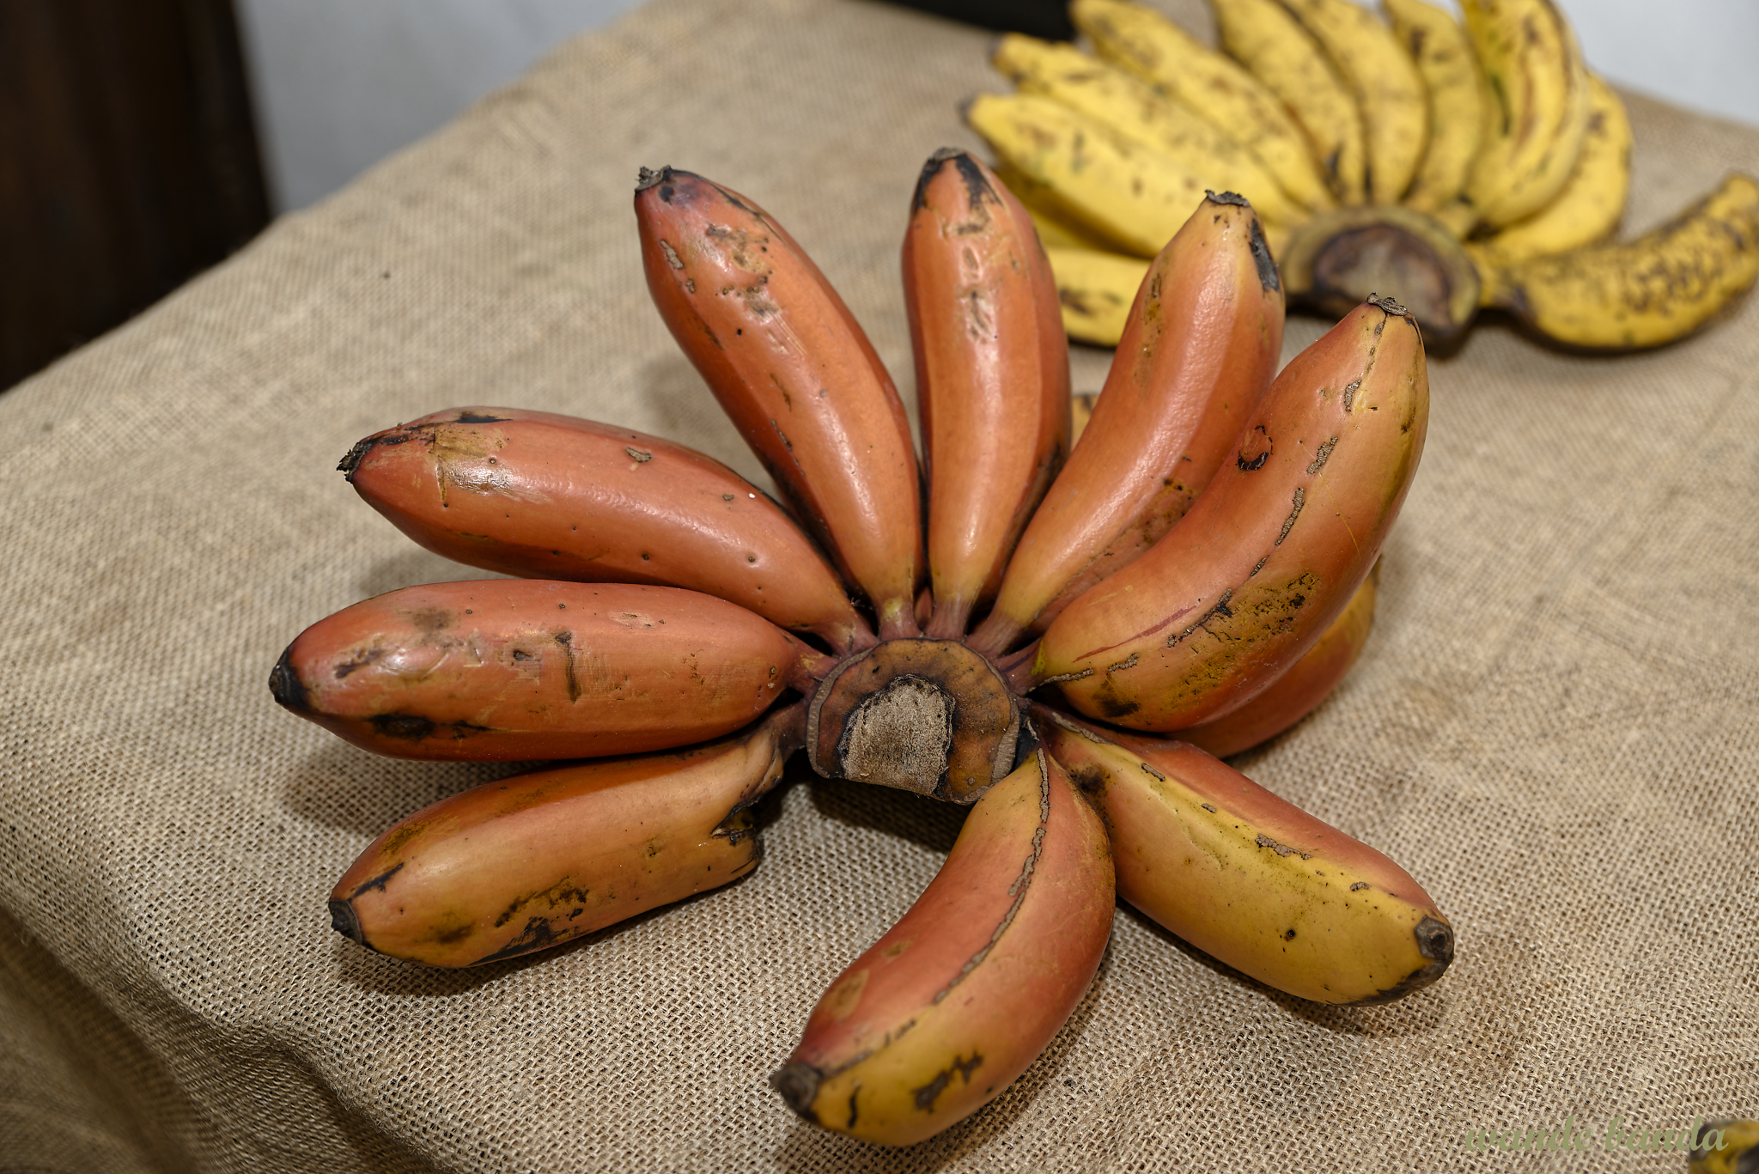 | 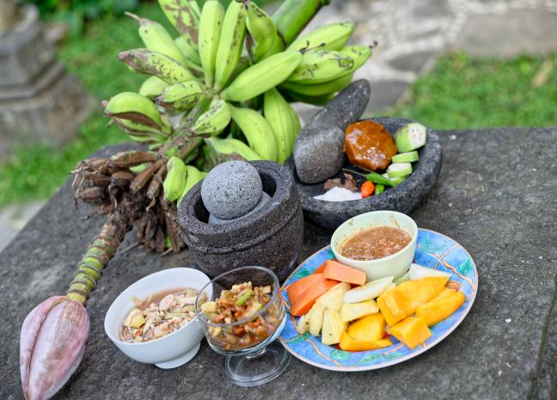
Pic.13. Pisang gendruwo | Pic. 14. Pisang kluthuk

