

CREATIVE FOOD EDUCATION IN INDONESIA
TO ENCOURAGE A SHIFT TOWARDS HEALTHY AND SUSTAINABLE DIETARY PATTERNS

Indonesia, as a country located on the equator and at the confluence of the two Rings of Fire, has earned it the nickname "paradise on earth." This gift from the Creator has endowed the country with extraordinary natural resources, including 77 types of carbohydrates, 73 types of fats, 26 types of nuts, 389 types of tropical fruits, 228 types of vegetables, and 100 types of spices.
The diversity of its human resources is also extraordinary. This country, nicknamed the "Nusantara" (Indonesian archipelago), has more than 1,300 ethnicities spread across 38 provinces. Statistics from 2020 recorded a population of over 270 million people, with over 70% of the population being in the productive age group. This productive age group ranges from 16 to 64 years old. Indonesia's rich human resources represent the largest population in the world, alongside the United States, China, and India.
Indonesia's natural and human resource strength is a source of great concern for other countries. Managing this strength is a shared responsibility, yet another aspect we must be vigilant about and understand going forward. Research from UNICEF, in collaboration with the Faculty of Medicine, University of Indonesia, and Wageningen University in the Netherlands (2021), indicates that decreased physical activity, the habit of consuming fast food, now known as Ultra Processed Food (UPF), and a decline in food diversity are contributing factors to the triple burden of malnutrition currently plaguing Indonesia. These three nutritional problems are malnutrition, overweight, and micronutrient deficiencies. Jee-Hyun Rah (UNICEF Indonesia, 2023) reported that one in four Indonesian adolescents suffers from stunting (short stature), one in seven is overweight, and a quarter of Indonesian adolescent girls suffer from anemia (female iron deficiency). The Triple Burden of Malnutrition in Indonesia increases susceptibility to disease, particularly Non-Communicable Diseases (NCDs), and also impacts the mental health and intelligence of Indonesians. Non-communicable diseases (NCDs), or catastrophic illnesses, are the largest contributor to global mortality. These include cancer, diabetes, heart disease, stroke, kidney failure, and more.
The most important factor in addressing all of this is food education at various levels, including formal education in schools and education within the smallest community, namely the household, through improving mothers' skills in nutrition and health.
Rumah KIBOO, an acronym for Kita Bhoga, is a space / home for expression through Food and Education. The Rumah (home) KIBOO founders' experience in various creative media and their experiences in various media outlets has sharpened their creativity, particularly in how Food Education in all aspects of life is crucial today, especially in the current era of media pressure without boundaries of space and time. The ongoing understanding of local food in the world of educational culture continues in Rumah KIBOO's activities, which include presentations related to the Food Pyramid for Supporting Achievement, known as 2BSA (Nutritious (Bergizi), Diverse (Beragam), Balanced (Berimbang), and Safe / Secure (Aman)).
Indonesia's staple food, specifically carbohydrates, is extremely diverse, with over 72 varieties. One such food ingredient is starch, derived from tubers and plant stem pith. Ganyong tubers and sugar palm stems are sources of starch that have long been used by Indonesians as ingredients for noodles. Noodles are a favorite source of carbohydrates, especially noodles preserved by drying.
Food culture is a pattern of acculturation that is highly variable. Changing dietary patterns must be anticipated by continuing to utilize local food sources. Rumah KIBOO always prioritizes this. Yards are also optimized for the supply of leading-edge food, tailored to the topography and a person's ability to easily execute the process. This is Rumah KIBOO's focus.

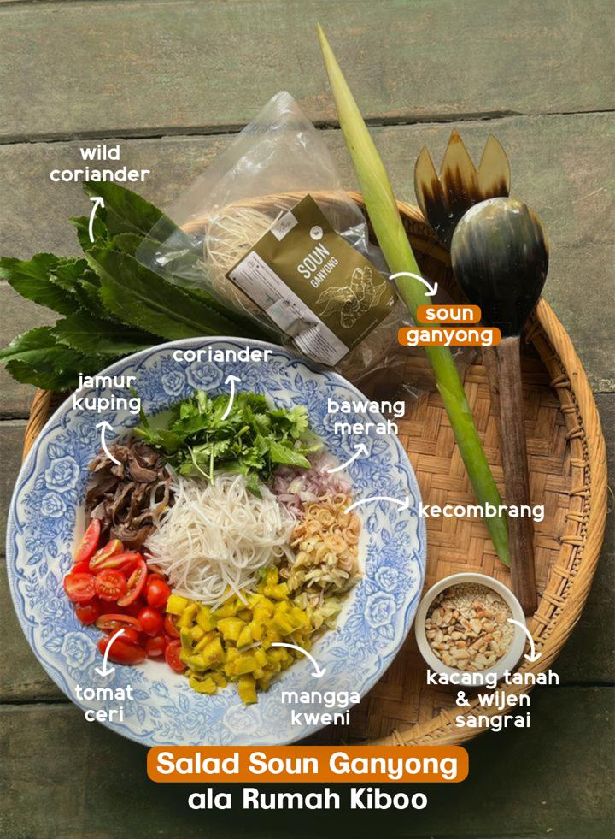
Pic 1. Gluten Free Noodle base on Artisan Indonesian Ingredients
(Cana edulis Kerr starch)

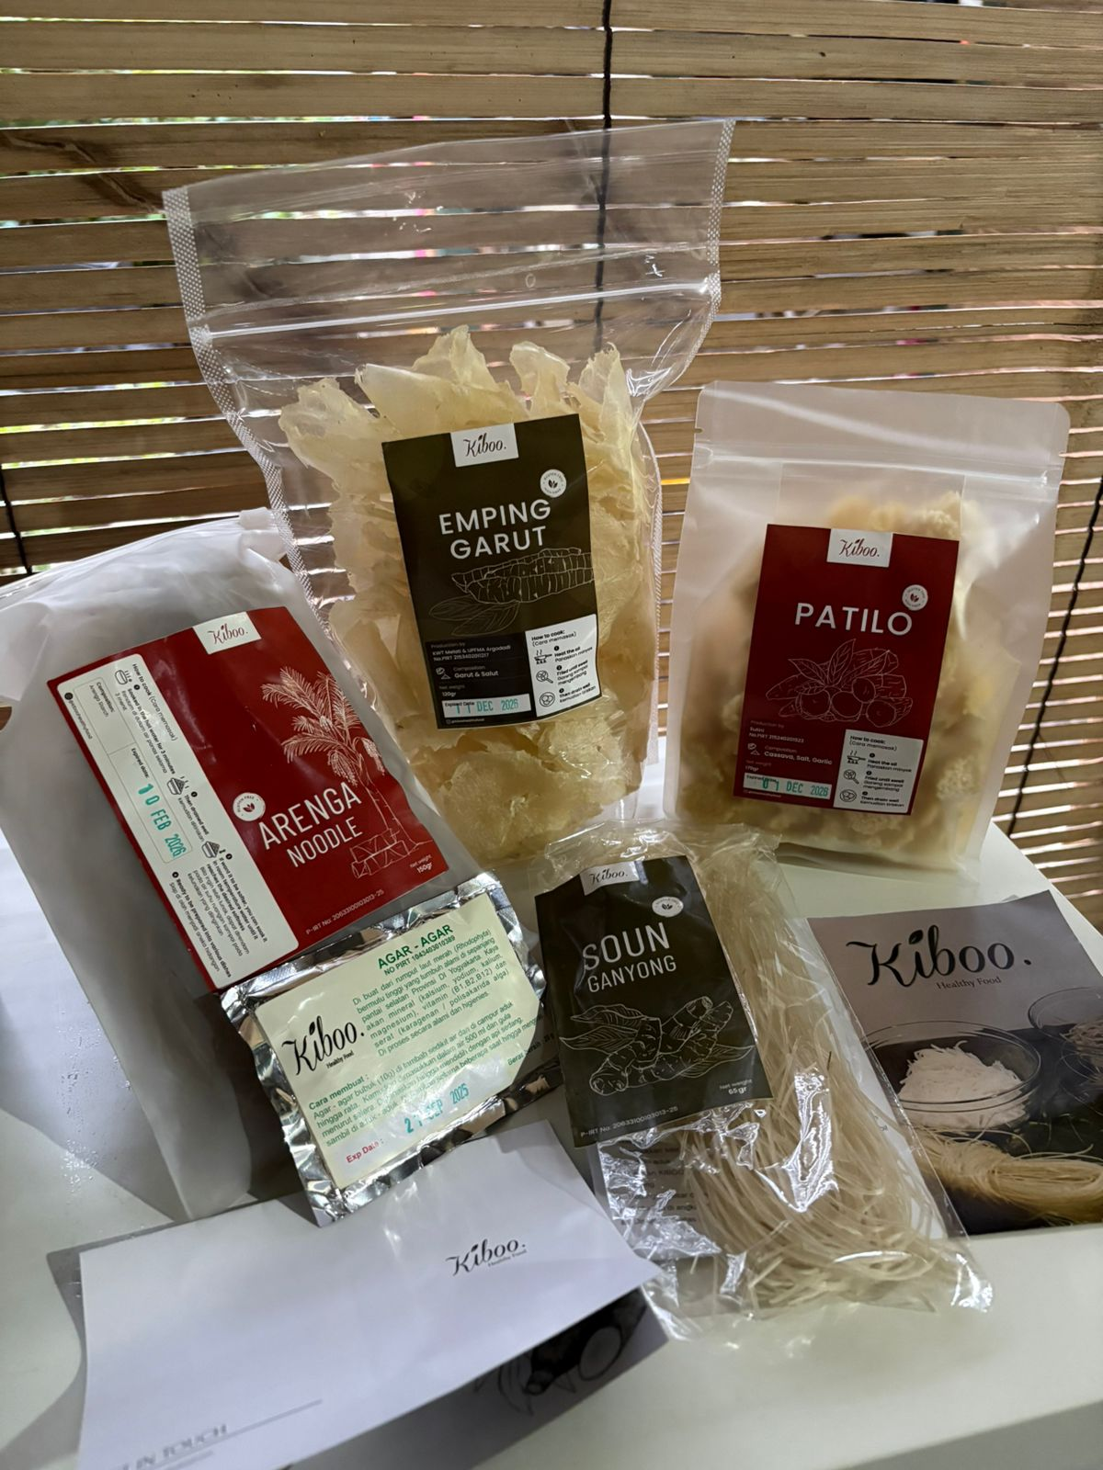
Pic. 2. Diversity Indonesian Food Product

